What Is Azure Storage

The Azure Storage platform is Microsoft's cloud storage solution for modern data storage scenarios. Azure Storage offers highly available, massively scalable, durable, and secure storage for a variety of data objects in the cloud. Azure Storage data objects are accessible from anywhere in the world over HTTP or HTTPS via a REST API. Azure Storage also offers client libraries for developers building applications or services with .NET, Java, Python, JavaScript, C++, and Go. Developers and IT professionals can use Azure PowerShell and Azure CLI to write scripts for data management or configuration tasks. The Azure portal and Azure Storage Explorer provide user-interface tools for interacting with Azure Storage.

3D Azure Storage Concept

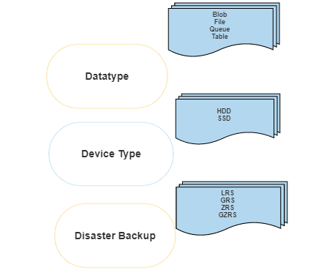

Redundancy (Disaster Backup)

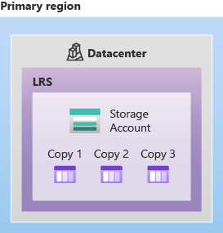

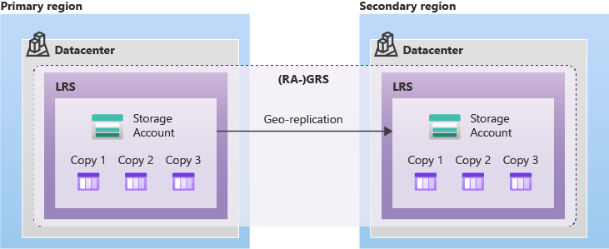

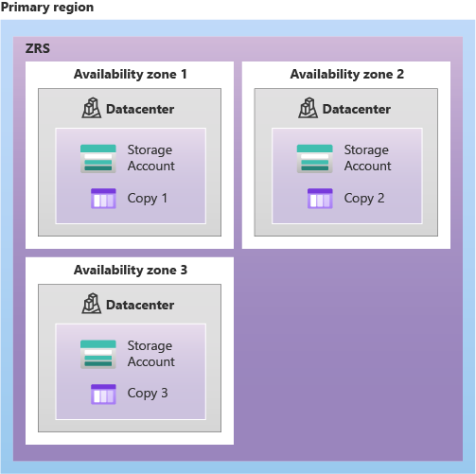

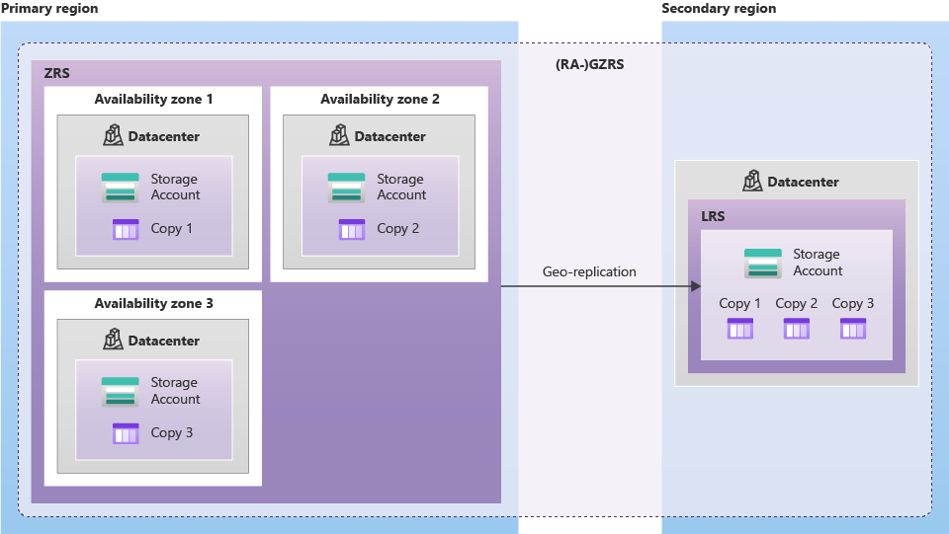

Azure Table

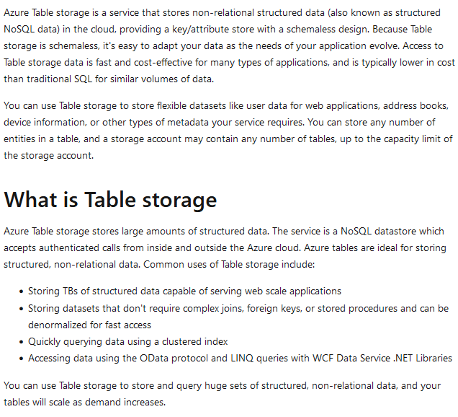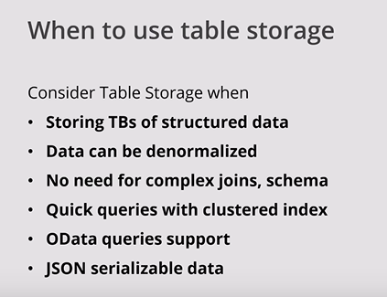

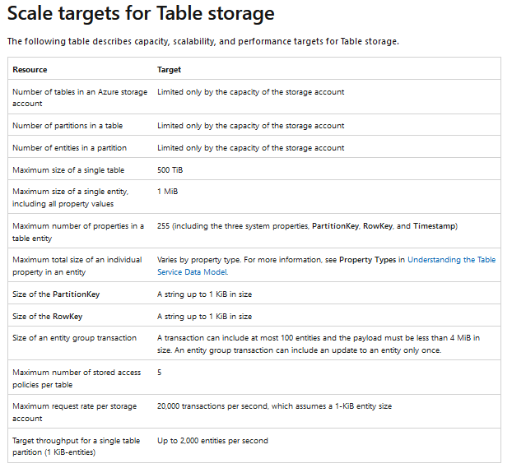

Azure Table vs Azure SQL

1. There is a fundamental difference between a SQL table and Azure table. While azure tables are capable of storing one type of data in a row and another type of data in an another row, SQL database tables are designed to store the same type of data in each and every row. This is because, relational databases enforce fixed schema and do not allow such flexibility. In Table storage, we refer to a row as an entity.
2. No store procedure
3. In an Azure Table, a unique row is identified by the combination pair of Partition key and Row key. In a relational database, a primary key is used to identify a unique row.
4. In an Azure Table, a unique row is identified by the combination pair of Partition key and Row key. In a relational database, a primary key is used to identify a unique row.
5. In terms of scalability, Azure Table is more scalable than Azure SQL.
6. Pricing: (2 gb 7.5 rs , 410 rs monthly storage, extra storage 1 gb 21 rs)

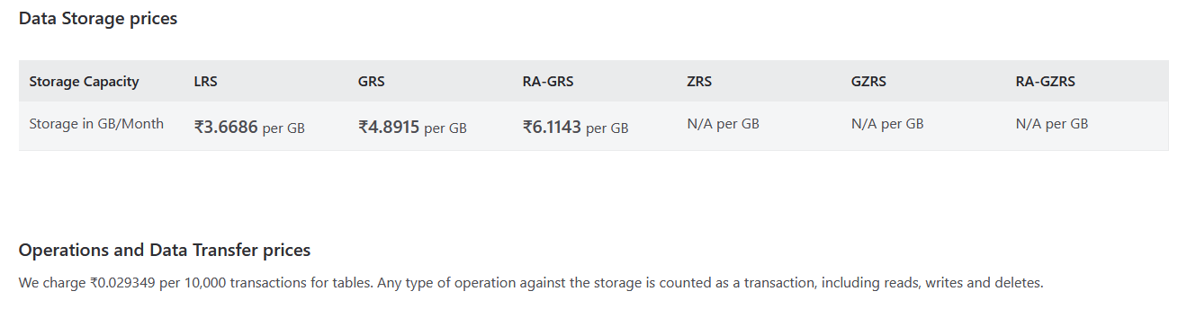

Azure Table vs Azure Cosmos

